**Name: Vinay Dattatray Shinde.**

**Roll: 230340325076**

***_Cloud section_***

Q1.

Solutions:

Note : The html code for the o/p on the public IP is as follows, also I have misspelled the word completed in the code. I request you to ignore it.

<html>

<body>

<h1> I have completed my first question for the cloud section </h1>

</body>

</html>

Screenshots:

1. Instance creation with time in it.

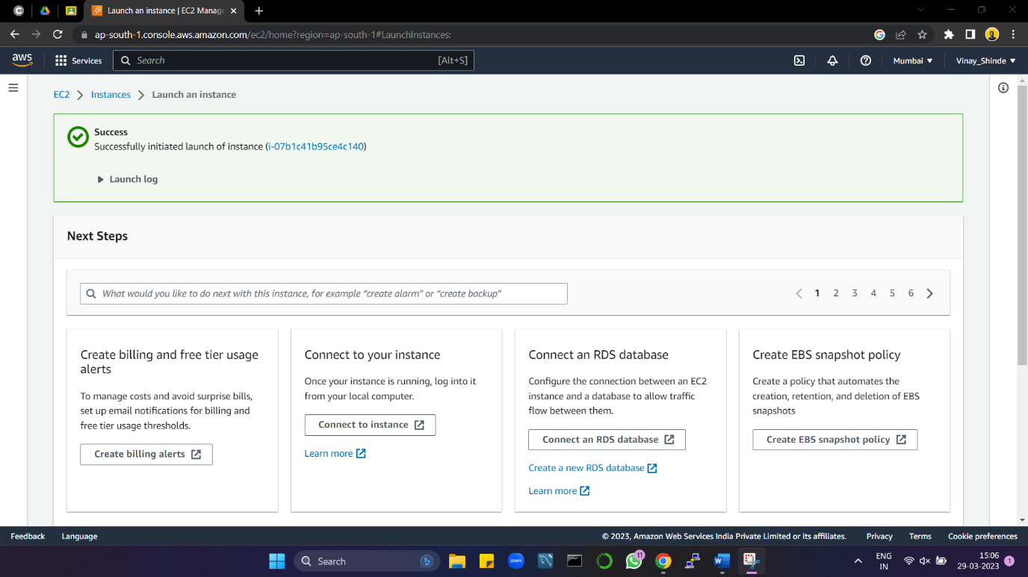

1. System commands in putty.

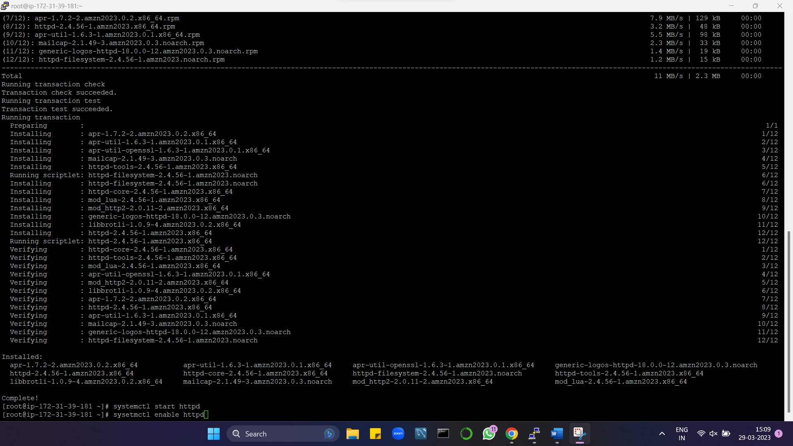

1. Screenshot after entering the html code in VI.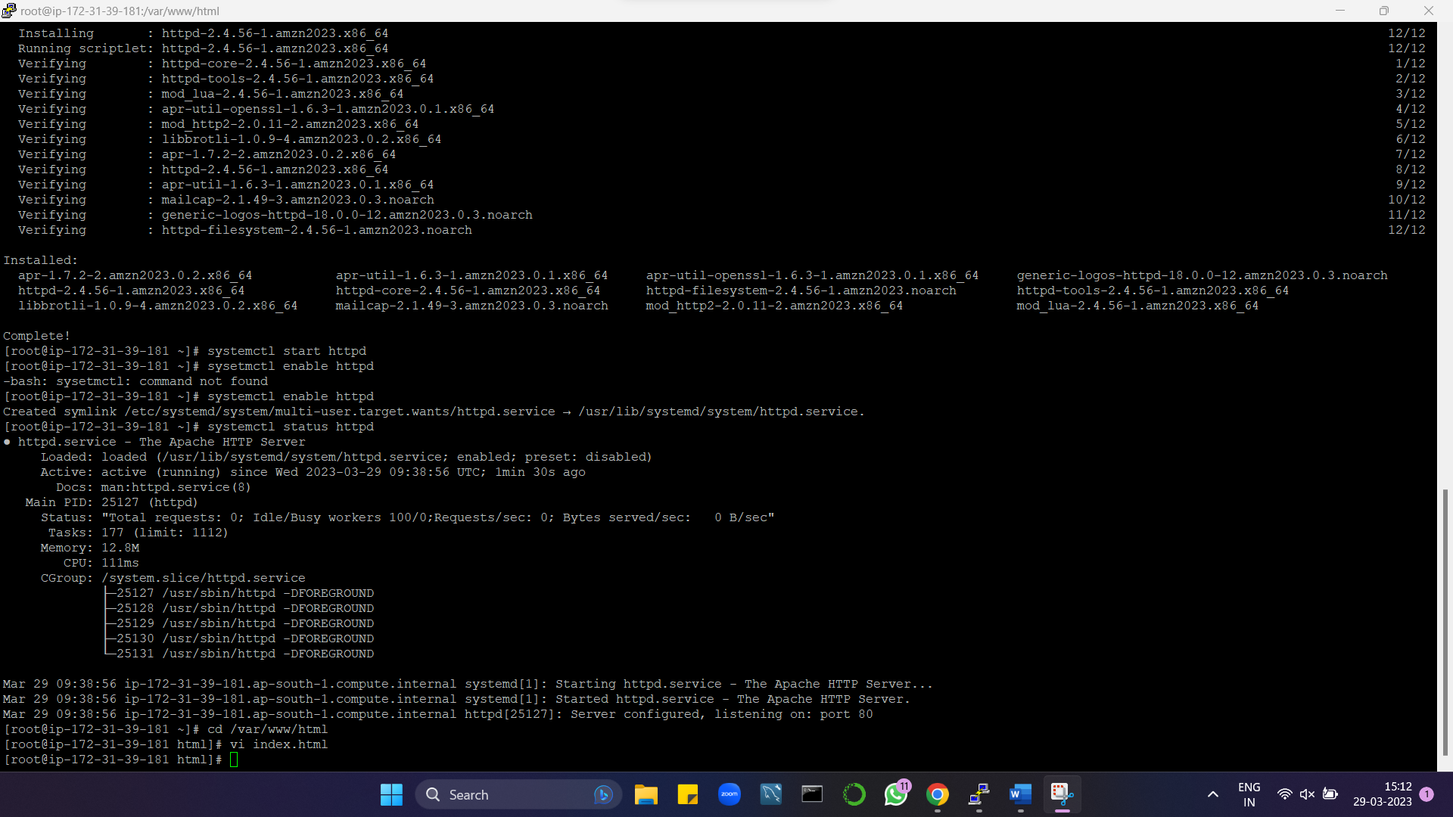
2. Final output.

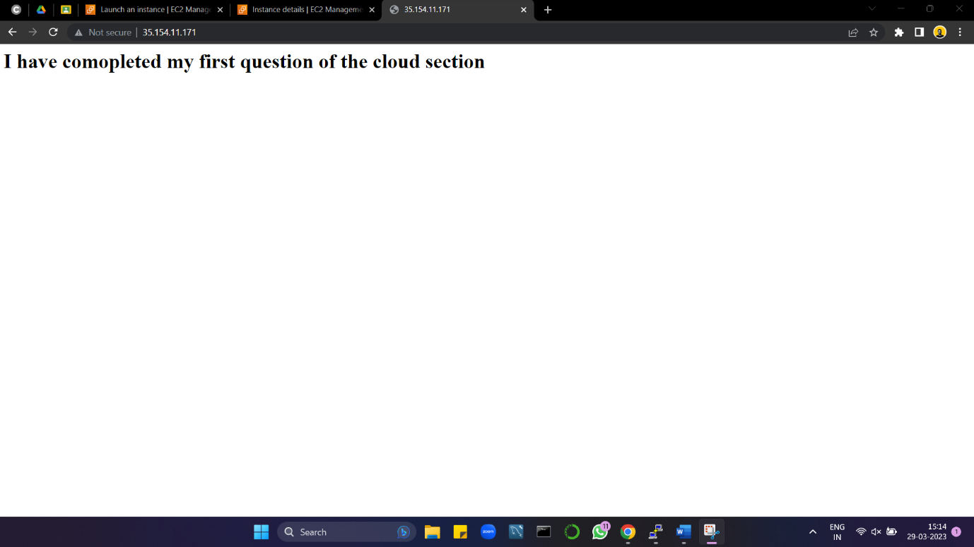

Q2.

1. Created a new user named jane.

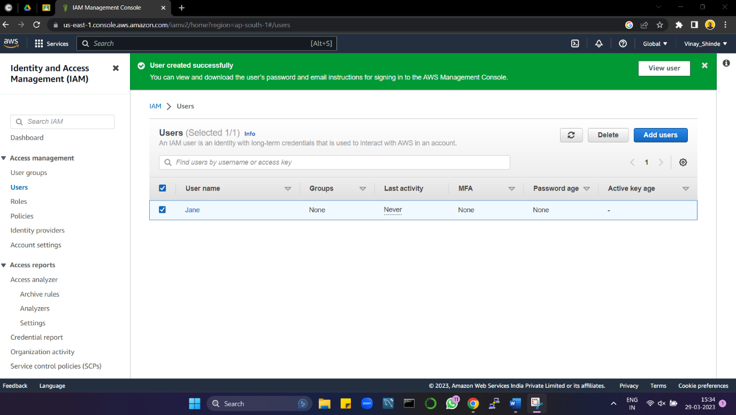

1. Created new group called devops

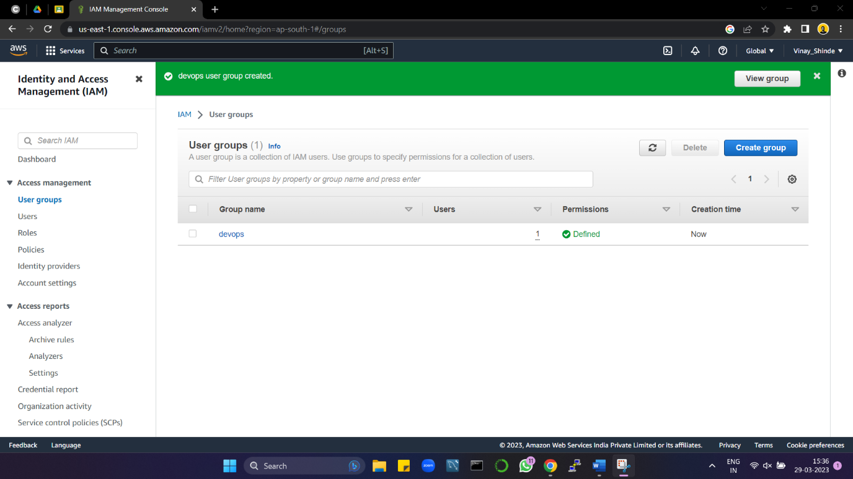

1. Created role s3 will ec2fullaccess.

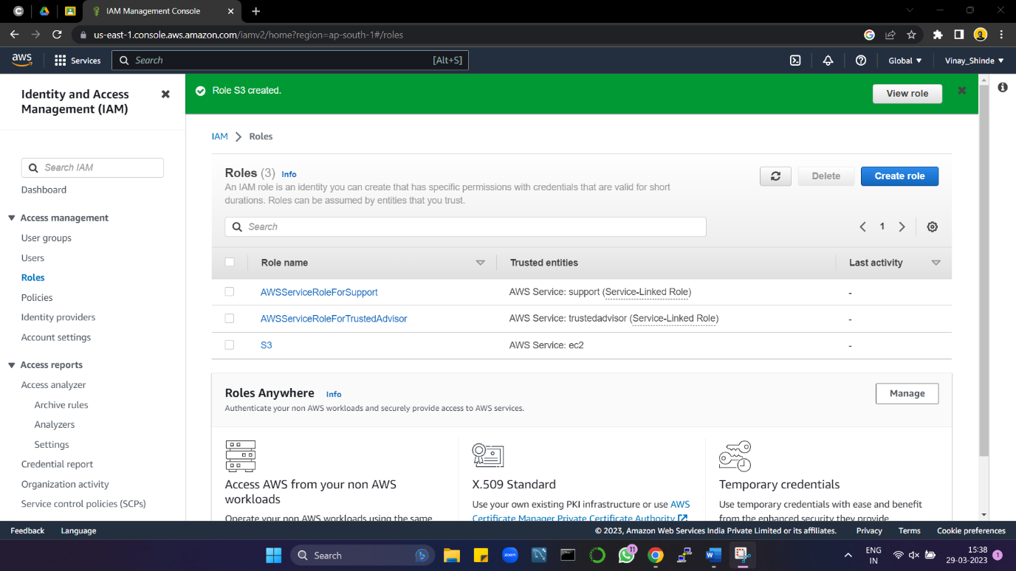

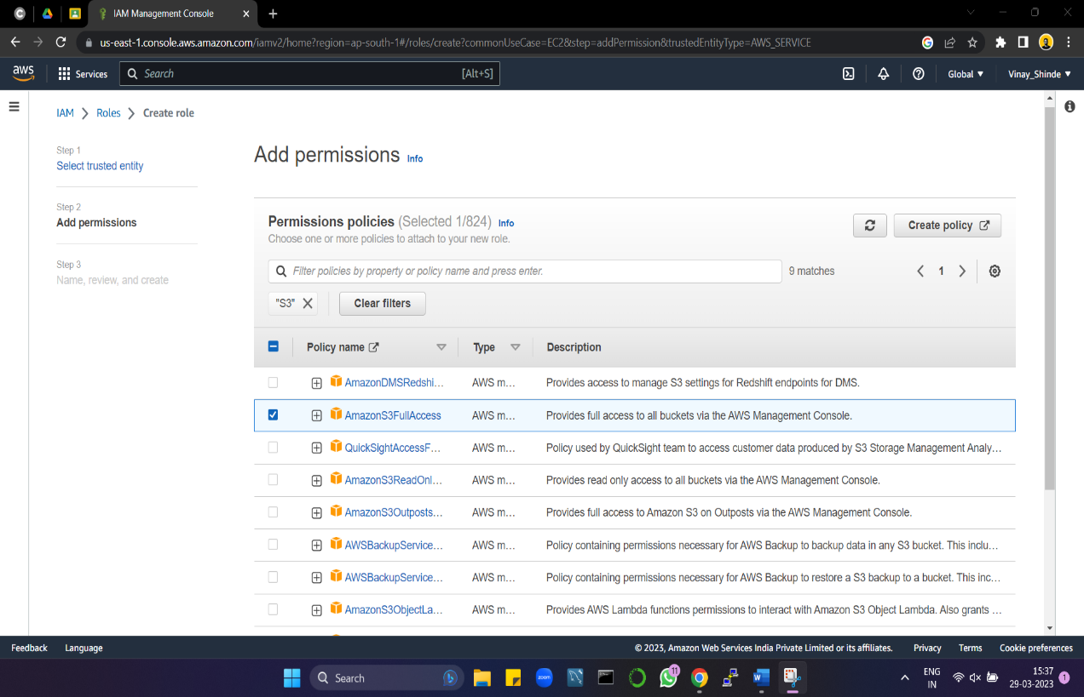

1. Checked for the permissions on the IAM policy simulator for jane in Creating & running the instances.

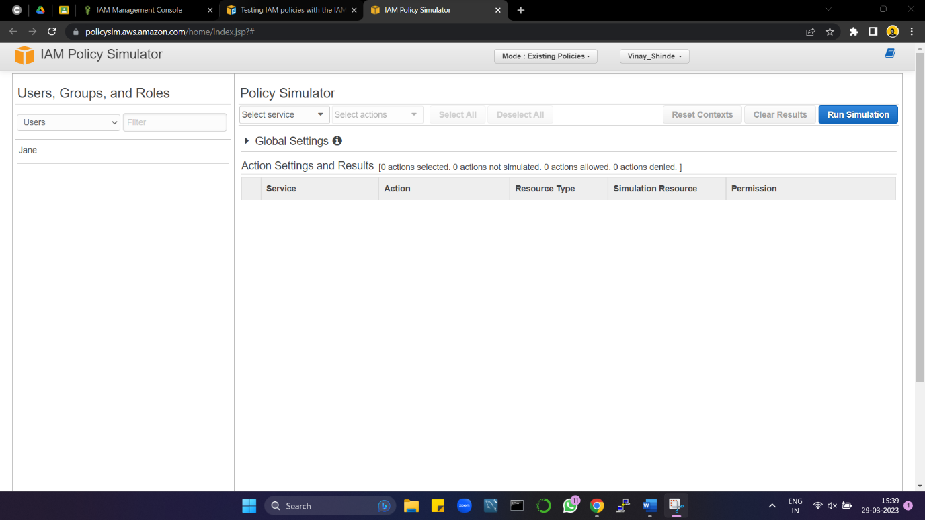

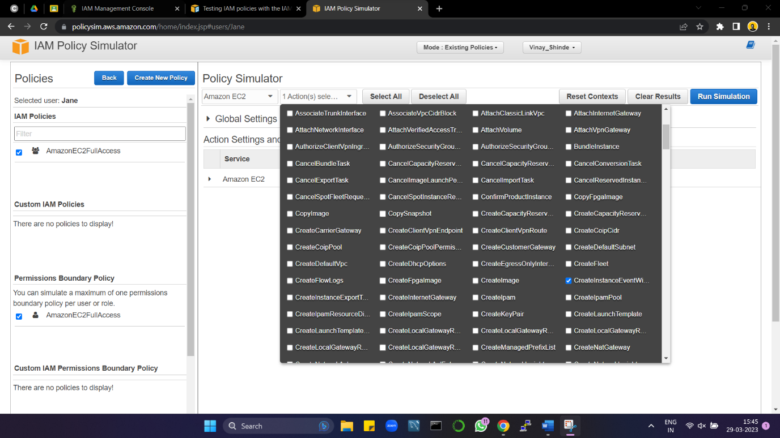

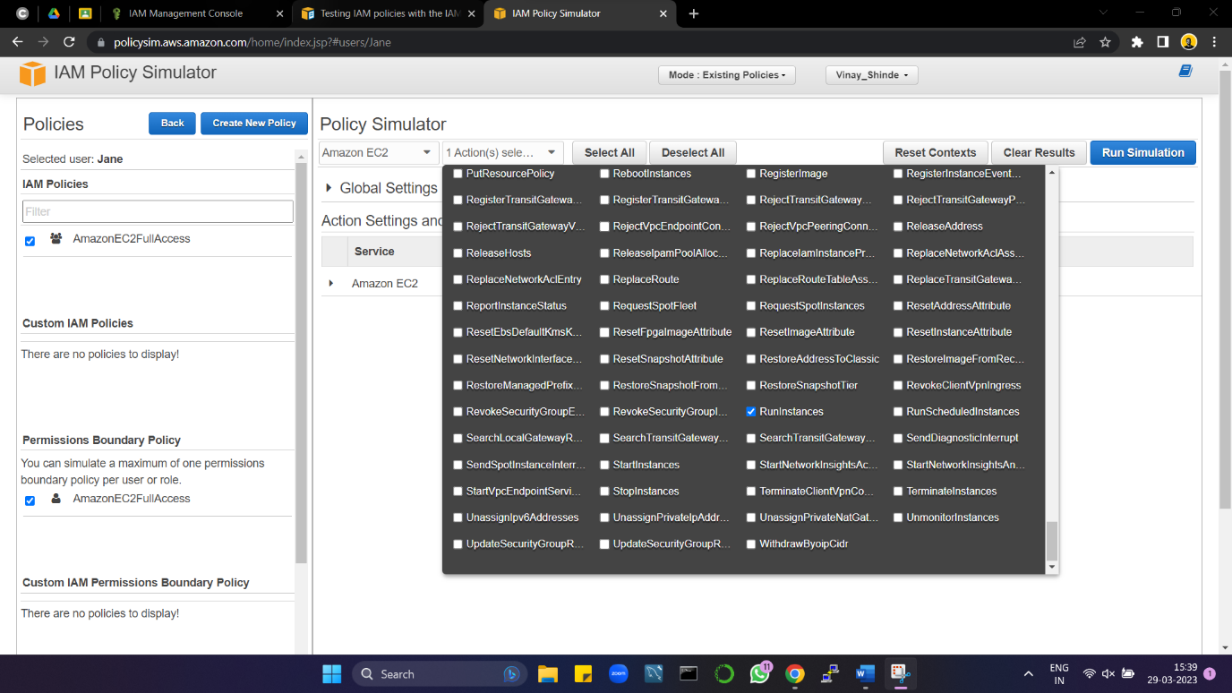

The simulation results are as follows:

1. For creating the instance.

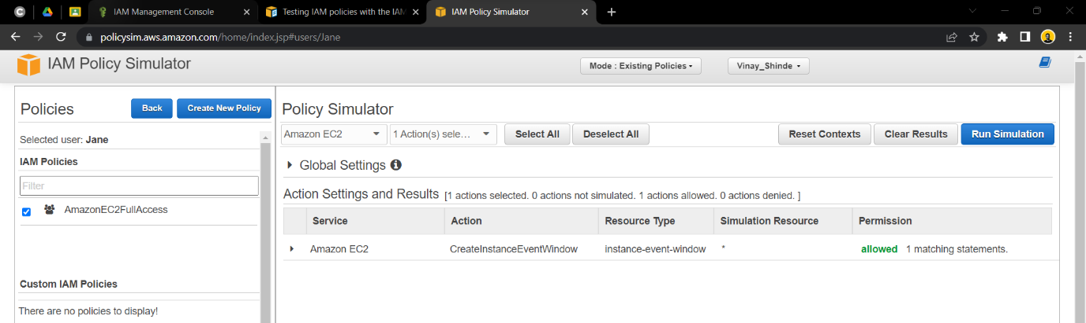

1. For running the instance.

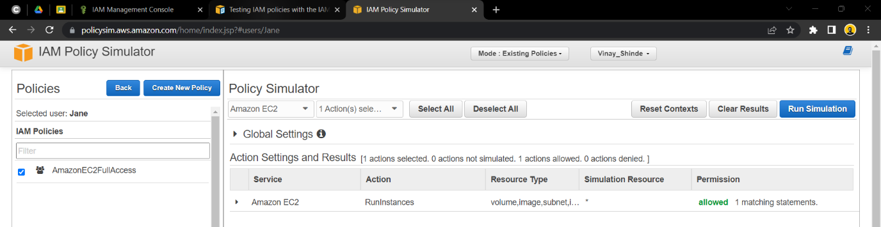

***_Linux section_***

Q1. Shell program for leap year.

Output : with different inputs

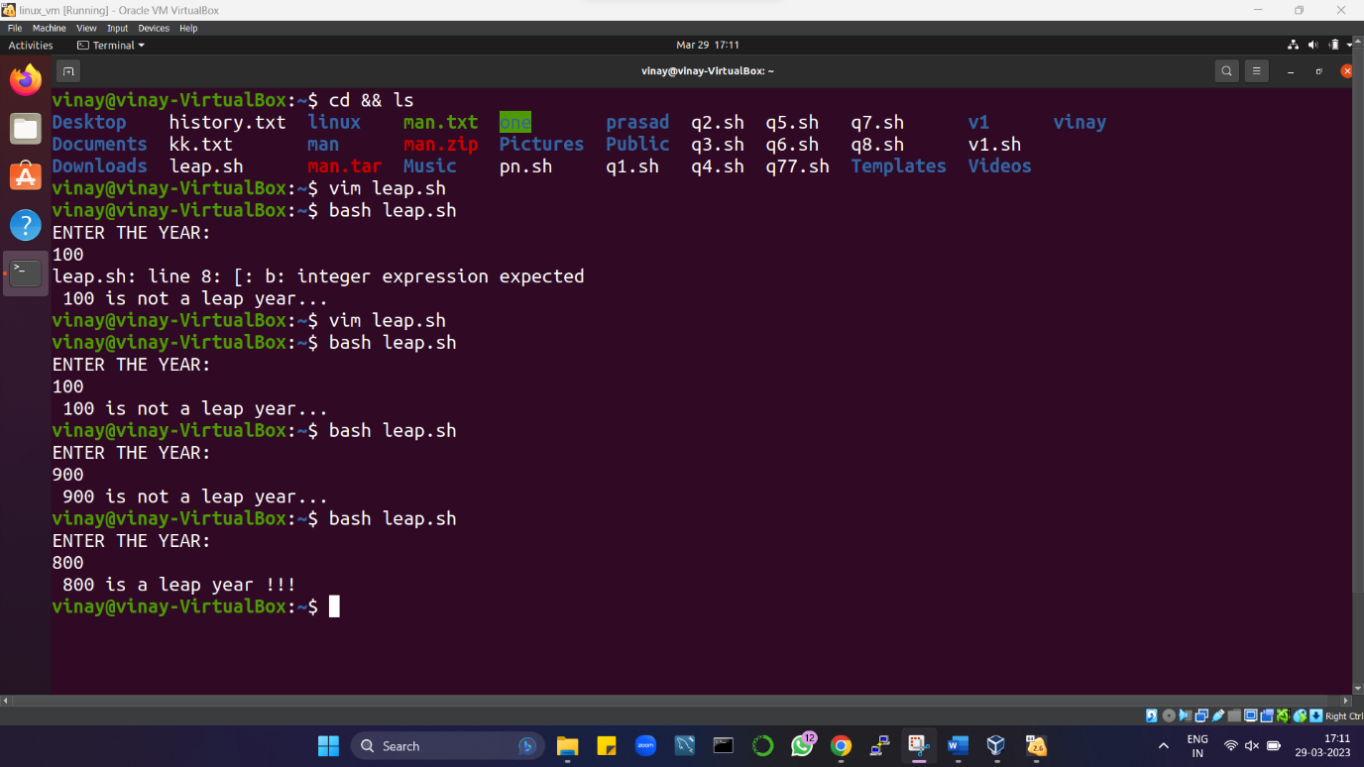

Code :

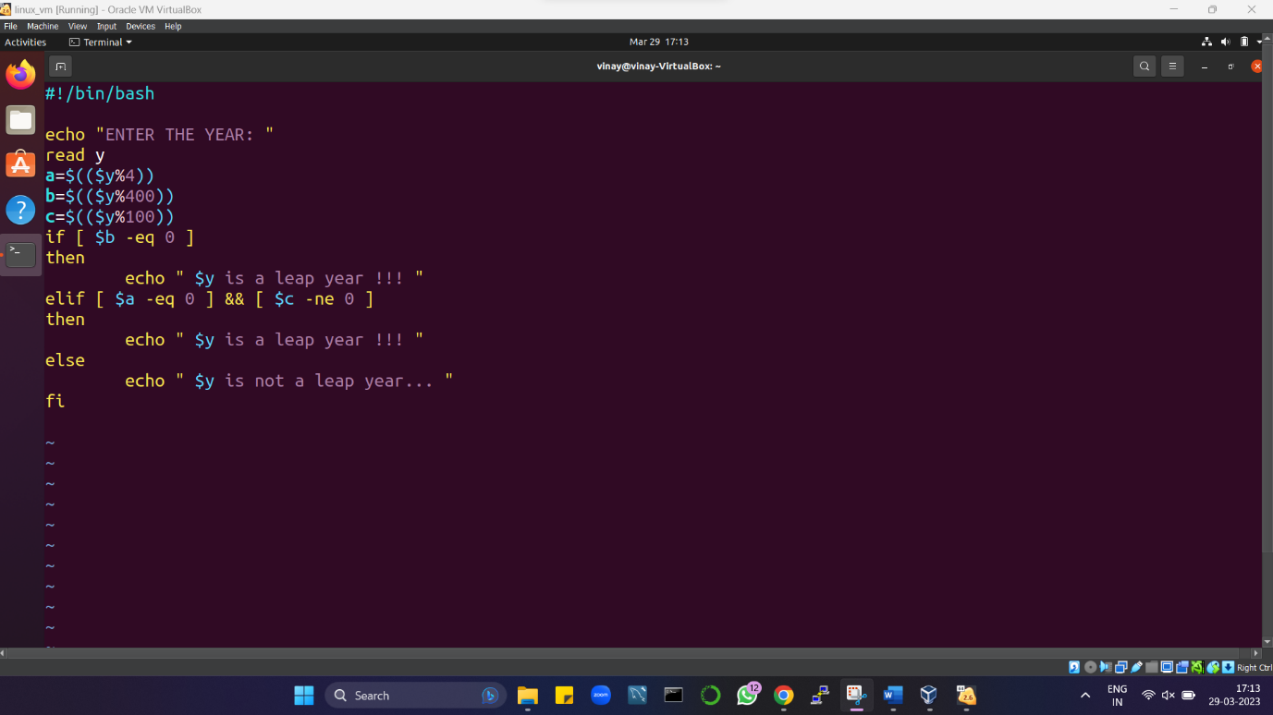

Q3. [Only attempted 3.1 & 3.2]

1. Created 2 directories dbda & dbda_B2 with **mkdir** command.
2. Changed the directory to dbda & created a file name **sep.txt** using the **touch** command.
3. Then used the **mv** command to rename the touch file as **Batch2.txt.**
4. Used **pwd** command to get a path & moved the file using **mv** command to dbda_B2 which we have previously created.
5. Also check whether the dbda directory is empty using **ls** command.
6. After moving the file to the new location used the **cd** & **ls** commands to get there & check if it was actually moved.
7. The file was moved.

